**Step 1: Setup Git Repository**

**Description:**  
Created a new folder git-ignore-lab and initialized it as a Git repository.

**Commands Used:**

git --version

mkdir git-ignore-lab

cd git-ignore-lab

git init

**Screenshot(s):**

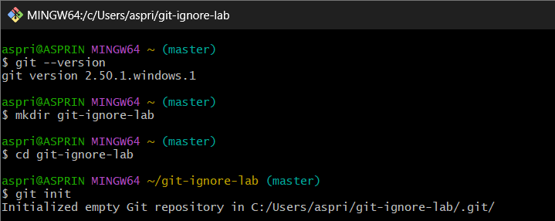

**Step 2: Create Sample Files**

**Description:**  
Created a .log file, a log folder with a file inside, and a normal text file.

**Commands Used:**

echo "Error log test" > test.log

mkdir log

echo "Some logs here" > log/error1.txt

echo "Hello Git" > readme.txt

**Screenshot(s):**  
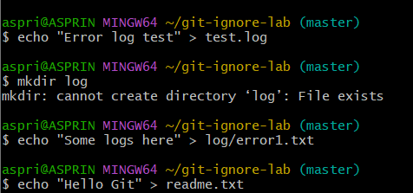

**Step 3: Create and Edit .gitignore File**

**Description:**  
Created .gitignore file and added rules to ignore .log files and the log folder.

**Commands Used:**

touch .gitignore

echo "*.log" > .gitignore

echo "log/" >> .gitignore

cat .gitignore

**Screenshot(s):**  
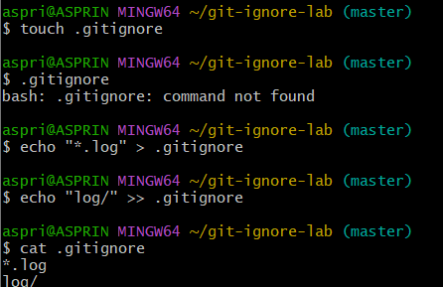

**Step 4: Verify Ignored Files**

**Description:**  
Checked git status to verify .log files and log/ folder are ignored.

**Commands Used:**

git status

git check-ignore -v test.log

git check-ignore -v log/error1.txt

**Screenshot(s):**  
